Bahria University,

Karachi Campus



LAB EXPERIMENT NO.

**07**

LIST OF TASKS

|  |  |
| --- | --- |
| TASK NO | OBJECTIVE |
| 1 | **Create static library that will used for three function, addition, multiplication, subtraction.** |
| 2 | **Create Dynamic library that will used for the multiple of 5.** |
| 3 | **Create static library that will used for cube of 10.** |

Submitted On:

**___________**

**Task # 01: Create static library that will used for three functions, addition, multiplication, subtraction.**

**Solution:**

#include<iostream>

#include"calc.h"

using namespace std;

int main(){

    cout<<"Enter first number"<<endl;

    int a,b;

    cin>>a;

    cout<<"Enter second number"<<endl;

    cin>>b;

    cout<<"Addition: "<<Addition(a,b)<<"\nSubtraction: "<<Substraction(a,b)<<"\nMultiplication: "<<Multiplication(a,b)<<endl;

    return 0;

}

Library Code:

#ifndef _calc_h_

#define _calc_h_

double Addition(int x, int y){

    return x+y;

};

double Substraction (int x, int y){

    return x-y;

};

double Multiplication (int x, int y){

    return x*y;

};

double Division(int x, int y){

    return x/y;

};

#endif

**Output:**

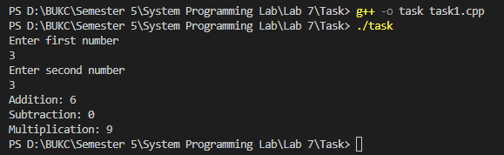

**Task # 02: Create Dynamic library that will used for the multiple of 5.**

**Solution:**

**Main file:**

#include<iostream>

#include"check5.cpp"

using namespace std;

int main(){

    cout<<"Enter number: ";

    int n;

    cin>>n;

    Check(n);

    return 0;

}

Libraries files

mul5.h file:

#ifndef _mul5_h_

#define _mul5_h_

void Check(int n);

#endif

check5.cpp file:

#ifndef mul5_C_

#define mul5_C_

#include "mul5.h"

using namespace std;

void Check(int num){

    if((num%5)==0){

        cout<< "Number is multiple of 5"<<endl;

    }

    else{

        cout<< "Number is not multiple of 5"<<endl;

    }

}

#endif

**Output:**

**Task # 03: Create static library that will used for cube of 10.**

**Solution:**

**Main File:**

#include<iostream>

#include"cube10.h"

using namespace std;

int main(){

    cout<<"Enter number: ";

    int n;

    cin>>n;

    if(n==10){

        cout<<"Cube: "<<cube10(n)<<endl;

    }

    else{

        cout<<"Number is not 10"<<endl;

    }

    return 0;

}

Library File:

Cube10.h:

#ifndef _cube10_h_

#define _cube10_h_

int cube10(int n){

    return n*n*n;

}

#endif

**Output:**

